# EXPERIMENT NUMBER –Final Practical Exam Computer Workshop

STUDENT’S NAME – Shinde Smita Shahaji

STUDENT’S UID – 20BCS4643

CLASS AND GROUP –CSE-IOT(GROUP B)

SEMESTER – 2ND

**TOPIC OF EXPERIMENT** – Write a program to determine if a number n is happy. A happy number is a number defined by the following process: Starting with any positive integer, replace the number by the sum of the squares of its digits. Repeat the process until the number equals 1 (where it will stay), or it loops endlessly in a cycle which does not include 1. Those numbers for which this process ends in 1 are happy. Return true if n is a happy number, and false if not.

# AIM OF THE EXPERIMENT –Introduction to Competitive World of Programming

PROGRAM CODE

class Solution {

public:

bool isHappy(int n) {

int ret, add=0;

if (n==1 || n== 7)

return true;

else if (n<10 && n!=1)

return false;

while(n>0)

{

add= add + pow((n%10),2);

n = n/10;

}

ret = isHappy(add);

if (ret == 1 || ret == 7)

return true;

return false;

}

};

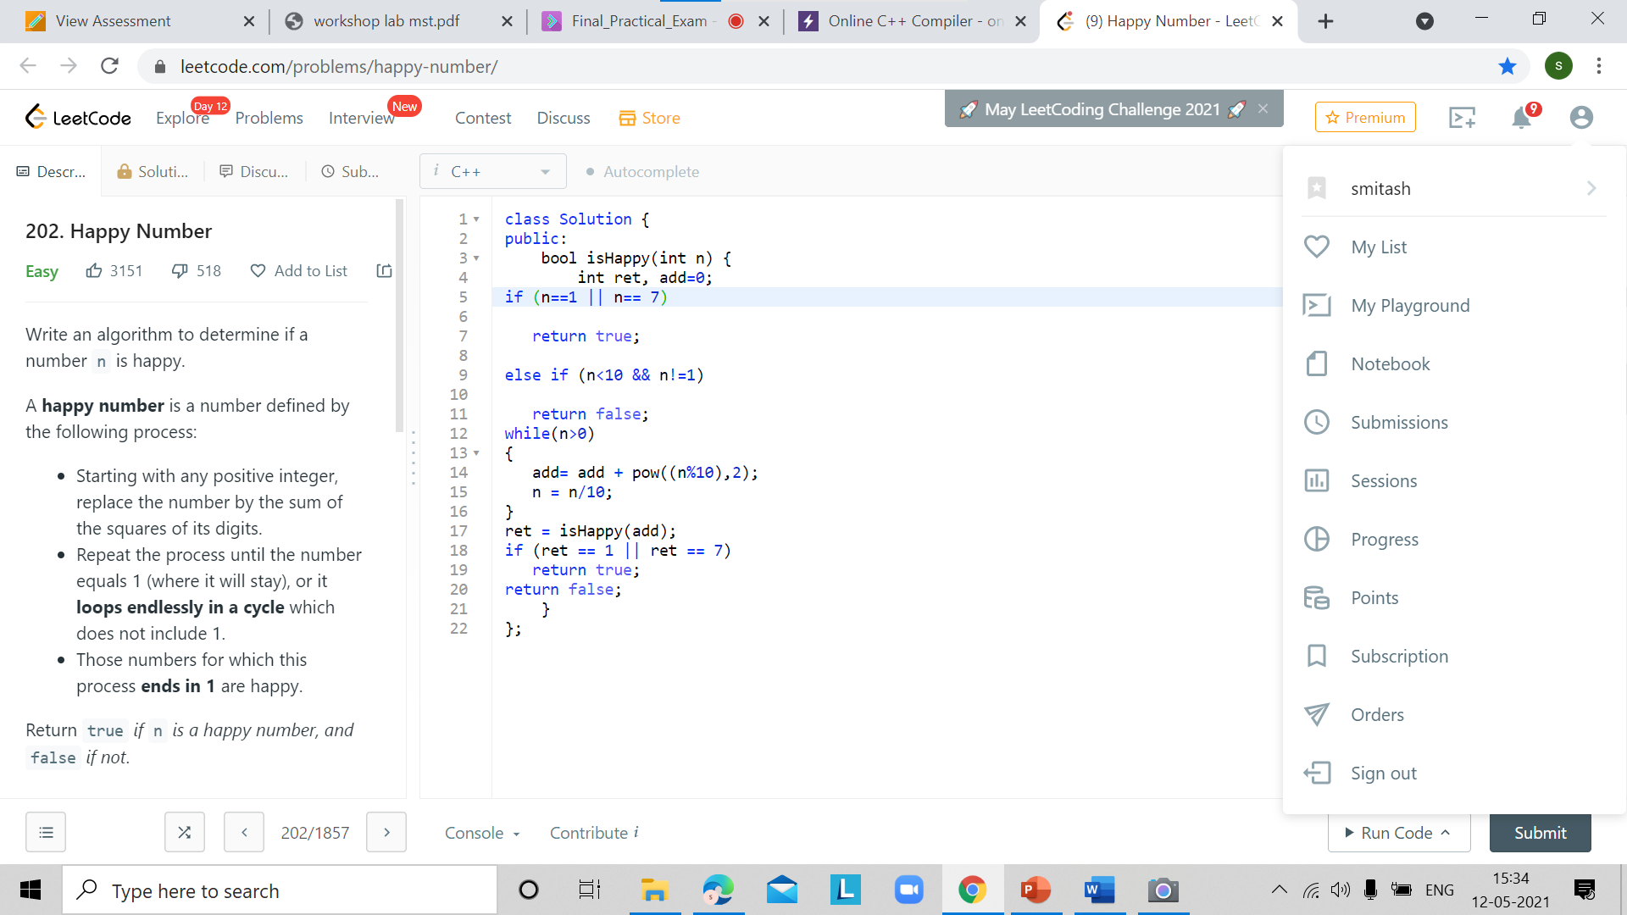

PROGRAMS’ EXPLANATION (in brief)

A happy number is a number defined by the following process:

Starting with any positive integer, replace the number by the sum of the squares of its digits.

Repeat the process until the number equals 1 (where it will stay), or it loops endlessly in a cycle which does not include 1.

Those numbers for which this process ends in 1 are happy.

OUTPUT

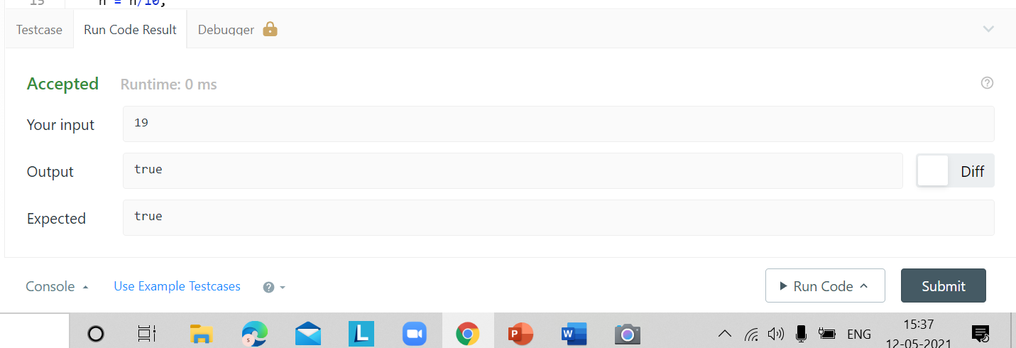

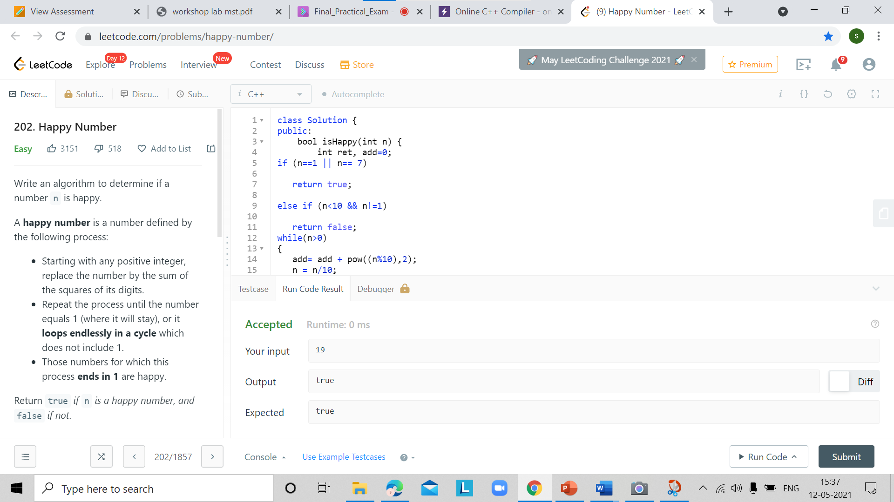

LEARNING OUTCOMES

1. Apply coding skills to solve application based problems on competitive platforms such as Hacker Rank/ Hacker Earth/Code Chef.
2. Understand the basic concept and structure of computer hardware
3. Identify the existing configuration of the computers and peripherals.
4. Installing and uninstalling multiple operating systems on a machine.
5. Apply their knowledge about computer peripherals to identify /rectify problems on-board.

EVALUATION COLUMN (To be filled by concerned faculty only)

|  |  |  |  |
| --- | --- | --- | --- |
| **Sr. No.** | **Parameters** | **Maximum**  **Marks** | **Marks**  **Obtained** |
| 1. | Worksheet Completion including writing learning objective/ Outcome | 10 |  |
| 2. | Post Lab Quiz Result | 5 |  |
| 3. | Student engagement in Simulation/ Performance/ Pre Lab Questions | 5 |  |
| 4. | Total Marks | 20 |  |